# DirectionCommandDelay:

# Aim of Software:

As to not cause damage to H-bridges when changing direction, there should be a pause of 1 second when a change in direction is requested. There should also signal that indicates that the direction is enabled. This enable signal will be used to enable speed commands to the X and Y axis PWM motor outputs.

# Unit Test:

**Test Set Up:**

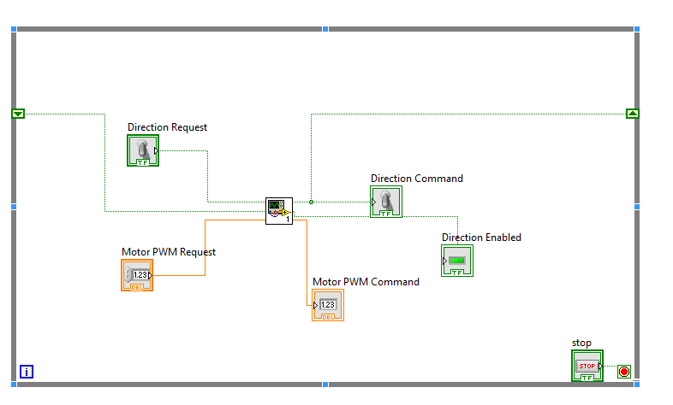

**Test Screenshots:**

1. When a direction is requested that is different to the current direction, the direction command should be equal to the current direction and the direction and speed command should not be enabled. CORRECT

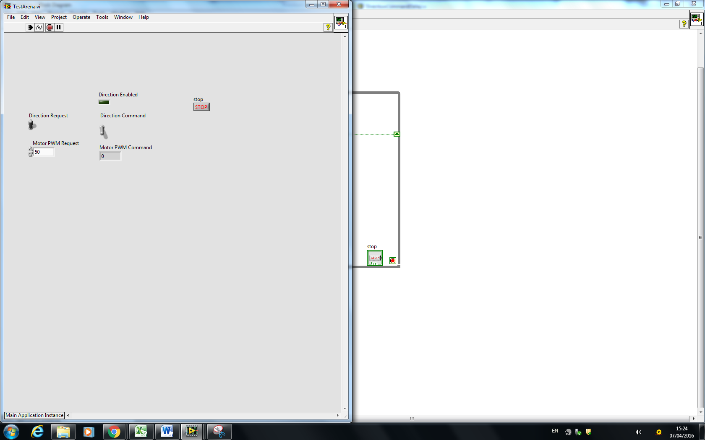

1. When ‘Direction Request’ is different to ‘Current Direction’, the direction command should be equal to the ‘Direction Request’ once 1s has elapsed . CORRECT

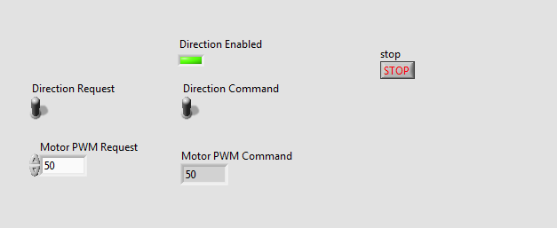.

# Integration Test:

Tested on Y-axis stepper motor in main manipulator VI with set up shown below

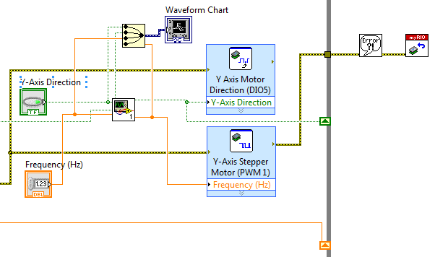

The direction delay works correctly as there is a 1 second delay when the direction request is altered. During the delay the PWM command is set to zero, turning the motor off.

